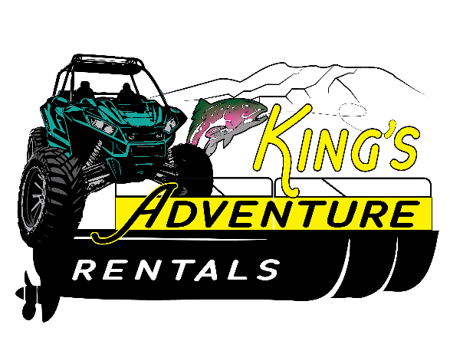
DAMAGE PROTECTION PROGRAM
The damage protection program offered by King’s Adventure Rentals allows renters to be protected from unexpected out of pocket costs in the event of major damage or total loss of one of our pontoon boats, aluminum boats or side by sides. Major damage or total loss of any boat or side by side caused by negligence, not following rules and regulations or an illegal act will immediately disqualify the renter from the damage protection program. The renter will be held financially responsible for the rented boat/side by side. (see below)
This program allows the pontoon boat or side by side renter to pay $50. If an accident or incident occurs during the rental period that causes severe damage or total loss of a pontoon boat or a side by side, the renter would be held liable for $2000 rather than the total value of the pontoon boat or side by side.
The aluminum boat charge for the damage protection program would be $25. If an accident or incident occurs during the rental period that causes severe damage or total loss of an aluminum boat, the renter would be liable for $750 rather than the total value of the aluminum boat.
Red/Teal Pontoon $27,000.00
Blue Pontoon $20,000.00
Aluminum Boats $2500.00 to $5000.00
Ranger 1000’s $19,000.00
CF Moto S x S $15,000.00
UTV Trailer $3,300.00 (Renter must provide Proof of Insurance)

